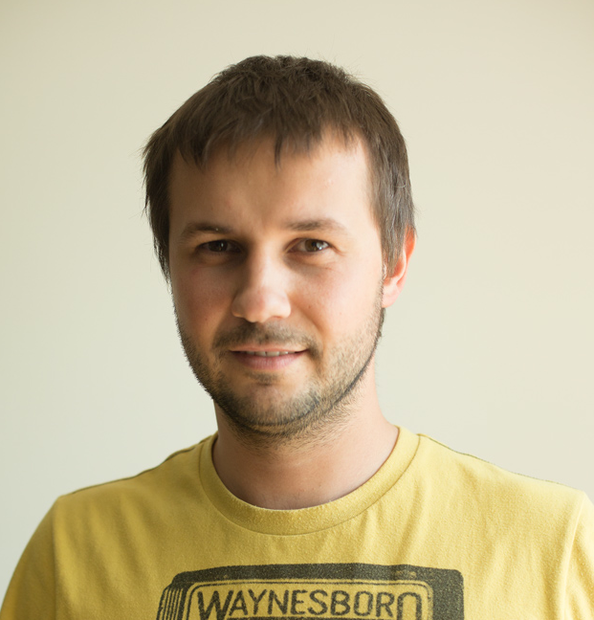

Directors biography - Miro Remo:

Miro Remo is originally from the industrial town of Ladce (Slovakia), where he attended elementary school. He barely finished his secondary school (gymnazium) in Považská Bystrica. As soon as he was accepted into the documentary film-directing program at the Academy of Performing Arts, he left his mechatronics studies to study in the film atelier of Vlado Balco at the Academy, where he currently continues to work. Miro is the holder of more than 40 awards from international film festivals. Miro’s most successful film so far is a portrait of his uncle and grandmother called Arsy-Versy. In terms of number of awards received, it is the most successful Slovak film ever. Currently, he is working on several original films and television programming. Comeback is his feature-length cinema debut.

Filmography:

Short and mid lenght movies for TV: Fotografi – Tibor Huszár – Návrat späť /Photographers – Tibor Huszár – Comeback (2011), – Sídliská – Beverly Hills 01863 /The Settlement – Beverly Hills 01863 (2012), Slovenské kino – Strach a napätie /Slovak Cinema – Fear and Thrill (2012), Pohoda / Pohoda Festival (2010), Konzervy času – Osmičkári / Time in a Can – The Eight-Boys (2011), Colnica – Ježkovy voči / The Customs– The Ježo View (2013), feature debut: Comeback (2014)

